**Windows and Linux Server Monitoring using Prometheus and Grafana**

## **What is prometheus?**

* Prometheus is a open source Linux Server Monitoring tool mainly used for metrics monitoring, event monitoring, alert management, etc.
* Prometheus has changed the way of monitoring systems and that is why it has become the Top-Level project of Cloud Native Computing Foundation (CNCF).
* Prometheus uses a powerful query language i.e. “PromQL”.
* In Prometheus tabs are on and handles hundreds of services and micro services.
* Prometheus use multiple modes used for graphing and dashboarding support.

## **Why we used prometheus?**

* A multi-dimensional data model with time series data identified by metric name and key/value pairs
* PromQL, a flexible query language to leverage this dimensionality
* Pushing time series is supported via an intermediary gateway
* Multiple modes of graphing and dashboarding support

## **Prometheus Architecture**

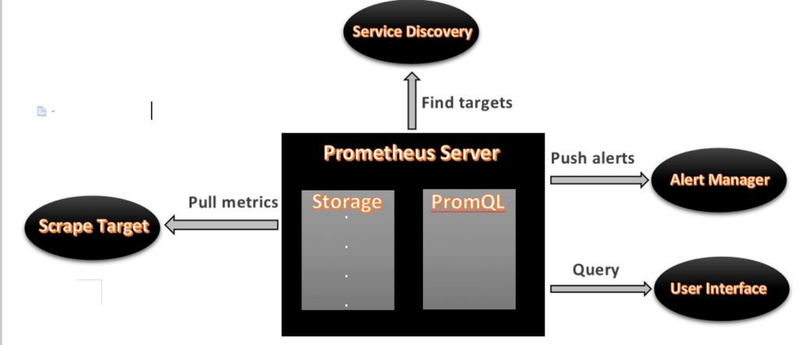

* As above we can see an architecture of Prometheus monitoring tool.
* We made a basic design to understand it easily for you people.

Now lets understand the Prometheus components one-by-one

## **Prometheus Components**

## **1. Prometheus Server**

* Prometheus server is a first component of Prometheus architecture.
* Prometheus server is a core of Prometheus architecture which is divided into several parts like Storage, PromQL, HTTP server, etc.
* In Prometheus server data is scraped from the target nodes and then stored in the database.

#### **1.a. Storage**

* Storage in Prometheus server has a local on disk storage.
* Prometheus has many interfaces that allow integrating with remote storage systems.

#### **1.b. PromQL**

* Prometheus uses its own query language i.e. PromQL which is a very powerful querying language.
* PromQL allows the user to select and aggregate the data.

## **2. Service Discovery**

* Next and very important component of Prometheus Server is the Service Discovery.
* With the help of Service discovery the services are identified which need to be scraped.
* To Pull metrics, identification of services and finding the targets are compulsory needed.
* Through Service discovery we monitor the entities and can also locate its targets.

## **3. Scrape Target**

* Once the services are identified and the targets are ready then we can pull metrics from it and can scrape the target.
* We can export the data of the end point using node exporters.
* Once the metrics or other data is pulled, Prometheus stores it in a local storage.

## **4. Alert Manager**

* Alert Manager handles the alerts which may occurs during the session.
* Alert manager handles all the alerts which are sent by the Prometheus server.
* Alert manager is one of the very useful components of the Prometheus tool.
* If in case any big error or any issue occurs, alert manager manage those alerts and contact with human via E-mail, Text Messages, On-call, or any other chat application service.

## **5. User Interface**

* User interface is also an important component as it builds a bridge between the user and the system.
* In Prometheus, user interfaces are note that much user friendly and can be used till graph queries.
* For good exclusive dashboards Prometheus works together with Grafana (visualization tool).
* Using Grafana over Prometheus to visualize properly we can use custom dashboards.
* Grafana dashboards display via pie charts, line charts, tables, good data graphs of CPU usage, RAM utilization, network load, etc with indicators.
* Grafana supports and run with Prometheus by querying language i.e. PromQL.
* To fetch data from Prometheus and to display the results on Grafana dashboards PromQL is used.

## **What is Grafana ?**

* Grafana is a free and open source visualization tool mostly used with Prometheus to which monitor metrics.
* Grafana provides various dashboards, charts, graphs, alerts for the particular data source.
* Grafana allows us to query, visualize, explore metrics and set alerts for the data source which can be a system, server, nodes, cluster, etc.
* We can also create our own dynamic dashboard for visualization and monitoring.
* We can save the dashboard and can even share with our team members which is one of the main advantage of Grafana.

## **What is Node Exporter ?**

* Node exporter is one of the Prometheus exporters which is used to expose servers or system OS metrics.
* With the help of Node exporter we can expose various resources of the system like RAM, CPU utilization, Memory Utilization, disk space.
* Node exporter runs as a system service which gathers the metrics of your system and that gathered metrics is displayed with the help of Grafana visualization tool.

## **What is WMI Exporter?**

* It is same like Node Exporter but Node Exporter for Linux and WMI Exporter for Windows
* WMI Exporter is an exporter utilized for windows servers to collects metrics like CPU usage, memory, and Disk usage.
* It is open-source which can be installed on Windows servers using the .msi installer

## **Prerequisite:**

Good internet connectivity

Security Groups Configured properly

Any web Browser

## #**1.** **Creating Prometheus System Users and Directory**

We will have to create a Prometheus user named Prometheus and a Prometheus directory named as Prometheus.

Using below commands we can create a user and directory.

sudo useradd --no-create-home --shell /bin/false prometheus

sudo useradd --no-create-home --shell /bin/false node_exporter

sudo mkdir /etc/prometheus

sudo mkdir /var/lib/prometheus

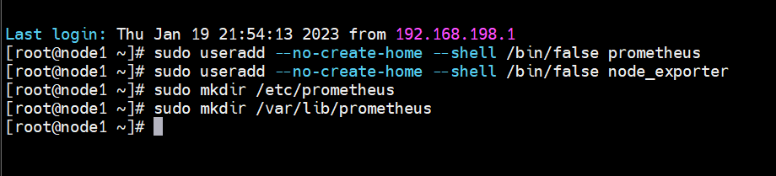

## #**2. Update Prometheus user**

sudo chown prometheus:prometheus /var/lib/Prometheus



## #3. **Download Prometheus Binary File on Linux**

Now we will download the latest version of Prometheus. We can copy the download link as per our Operating System from [Prometheus download page](https://prometheus.io/download/)

Using the below command we can download Prometheus, here we are downloading Prometheus x.x.x.x version, you use the above link to download specific version.

Navigate to /tmp directory

<https://github.com/prometheus/prometheus/releases/>

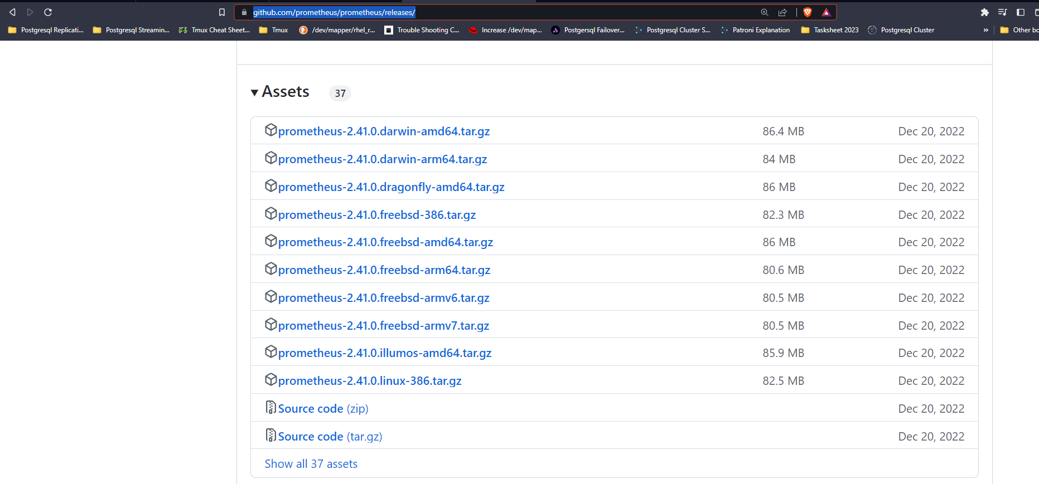

cd /tmp/

wget <https://github.com/prometheus/prometheus/releases/download/v2.41.0/prometheus-2.41.0.linux-386.tar.gz>

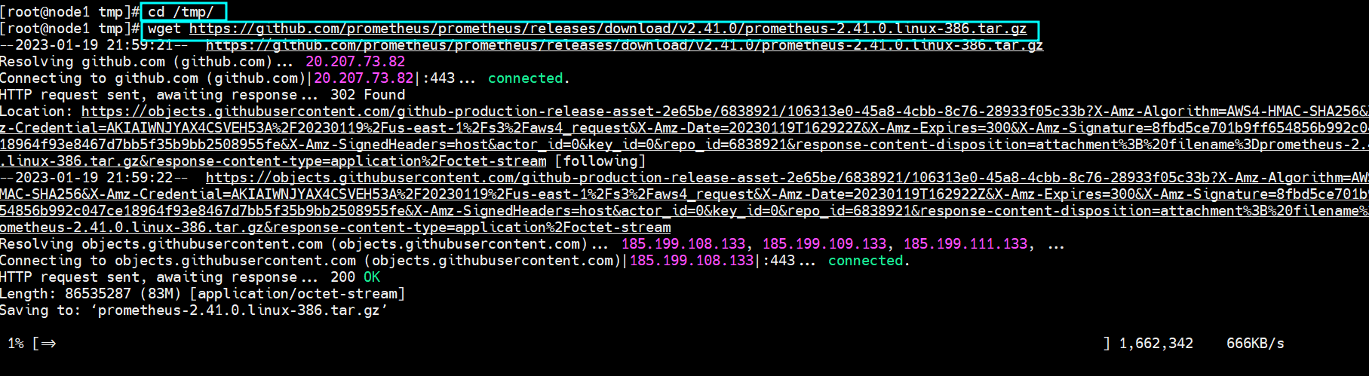

Now we have successfully downloaded the Prometheus file and now we will extract that file.

## #**4. Install Prometheus and Grafana on Linux**

Extract the files using tar command

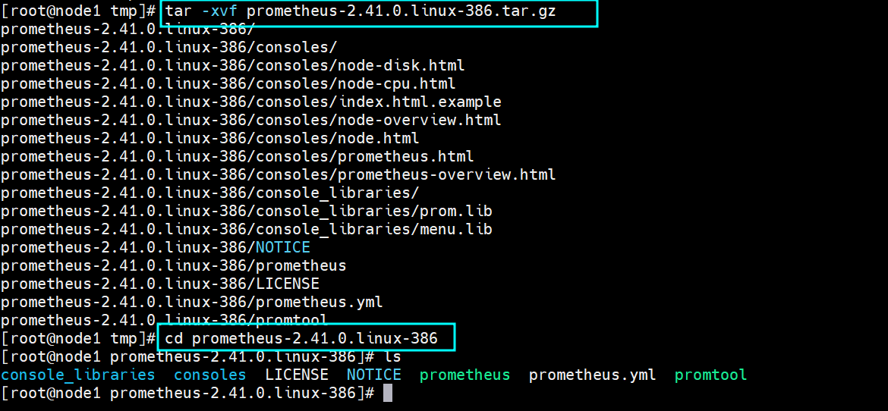

sudo mv console* /etc/Prometheus

sudo mv prometheus.yml /etc/Prometheus

sudo chown -R prometheus:prometheus /etc/Prometheus

## #**6. Update Prometheus user ownership on Binaries**

Now we will update the user and group ownership on the binaries of Prometheus.

Using following commands we will update the user and group ownership.

sudo mv prometheus /usr/local/bin/

sudo chown prometheus:prometheus /usr/local/bin/Prometheus

## #**7. Check Prometheus Version**

prometheus –version

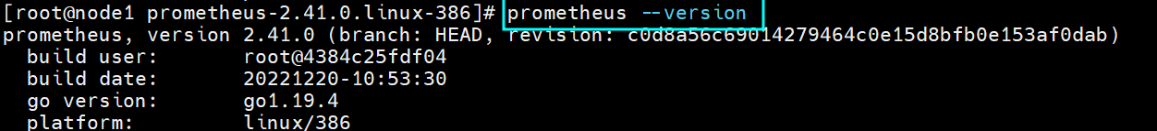

## #**8. Prometheus configuration file**

Don’t change anything

sudo nano /etc/systemd/system/prometheus.service

## #**9. Creating Prometheus Systemd file**

sudo nano /etc/systemd/system/prometheus.service

[Unit]

Description=Prometheus

Wants=network-online.target

After=network-online.target

[Service]

User=prometheus

Group=prometheus

Type=simple

ExecStart=/usr/local/bin/prometheus \

--config.file /etc/prometheus/prometheus.yml \

--storage.tsdb.path /var/lib/prometheus/ \

--web.console.templates=/etc/prometheus/consoles \

--web.console.libraries=/etc/prometheus/console_libraries

[Install]

WantedBy=multi-user.target

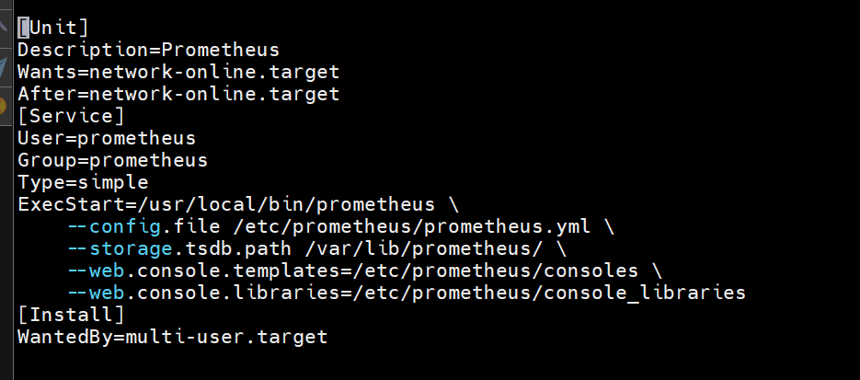

Save the file

sudo systemctl daemon-reload

start and enable prometheus service using below commands

sudo systemctl start prometheus

sudo systemctl enable prometheus

sudo systemctl status prometheus

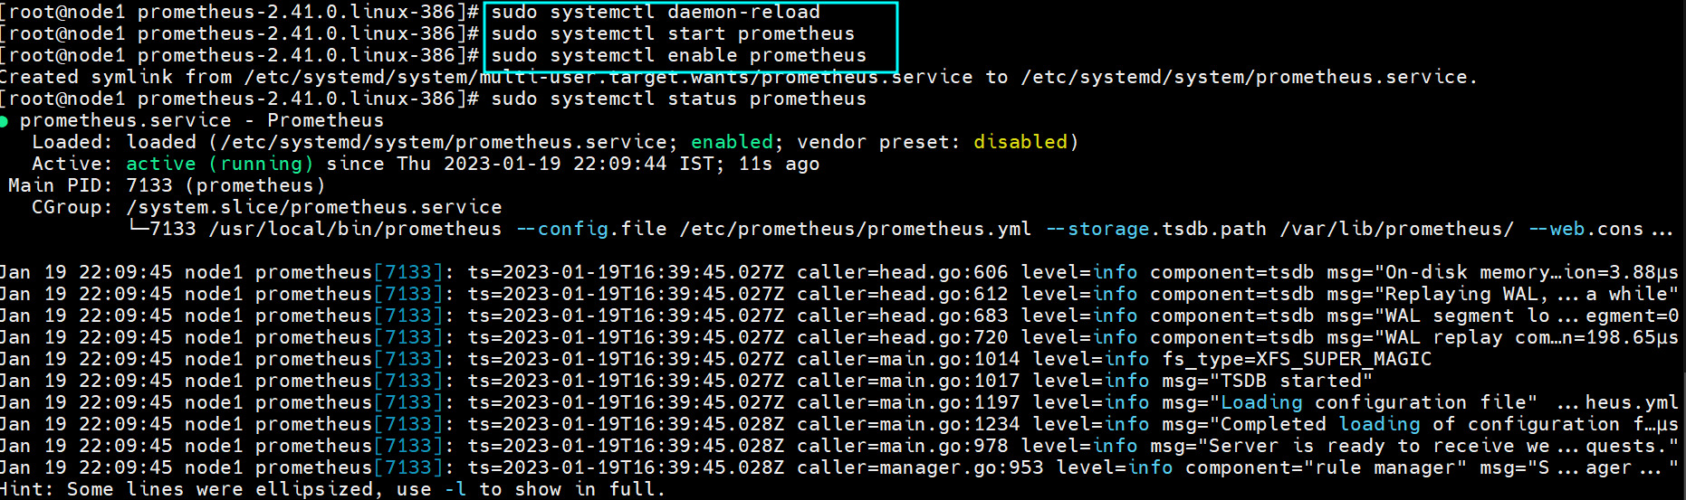

## **Accessing Prometheus on Browser**

<http://server-IP-or-Hostname:9090>

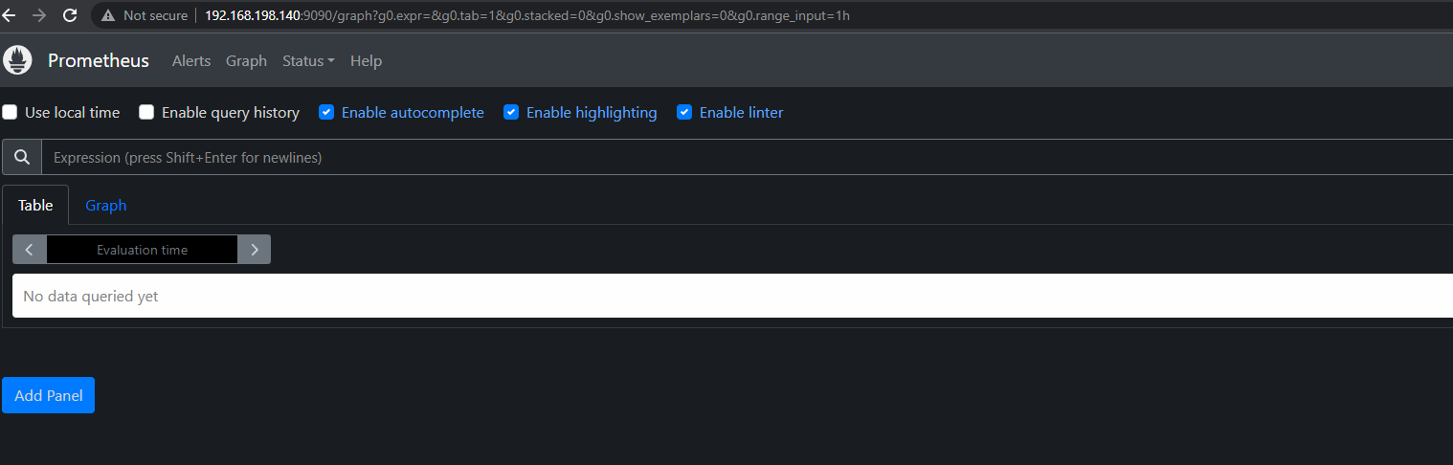

## **#11. Install Grafana on Linux**

<https://grafana.com/grafana/download>

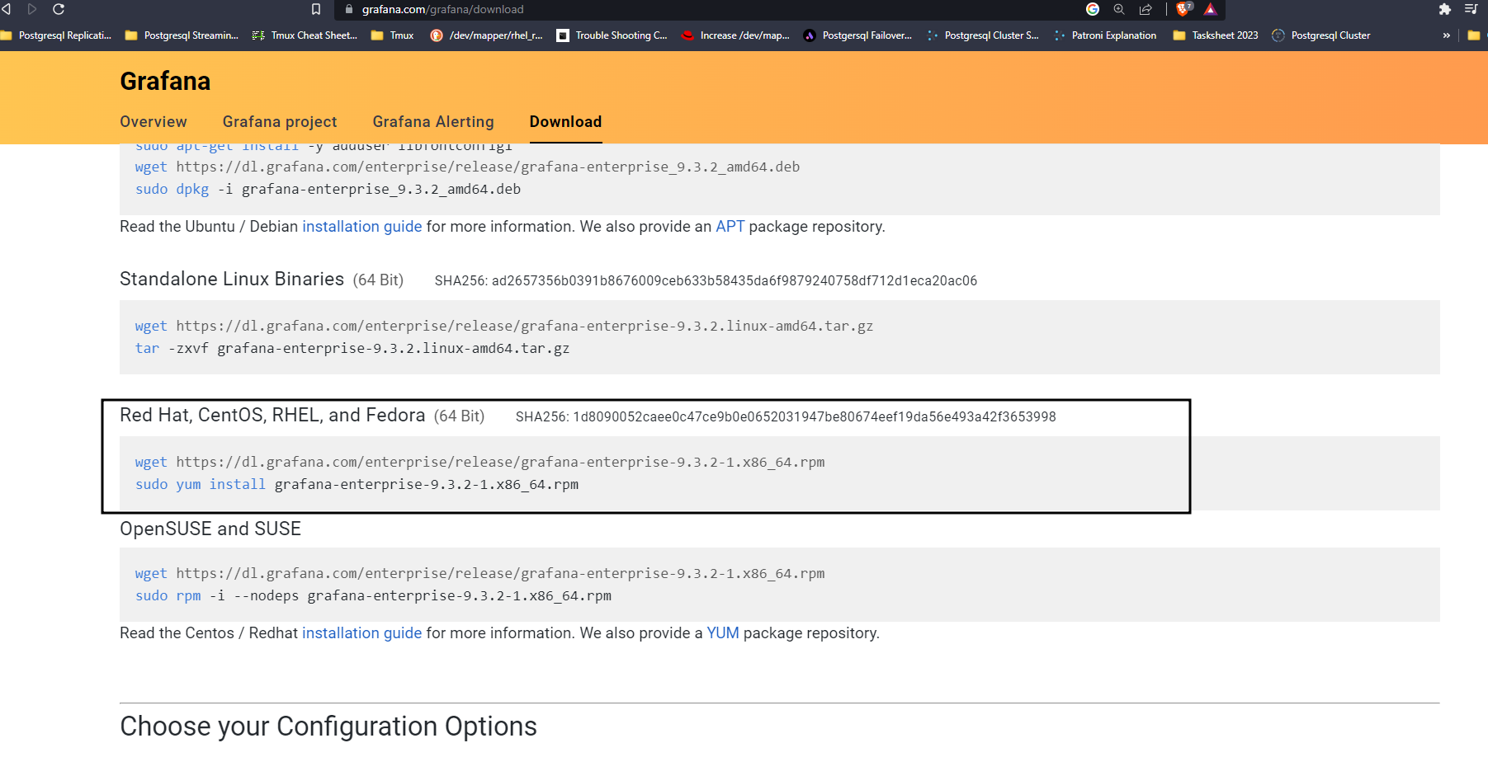

wget <https://dl.grafana.com/enterprise/release/grafana-enterprise-9.3.2-1.x86_64.rpm>

yum install grafana-enterprise-9.3.2-1.x86_64.rpm  
sudo systemctl start grafana-server

sudo systemctl status grafana-server

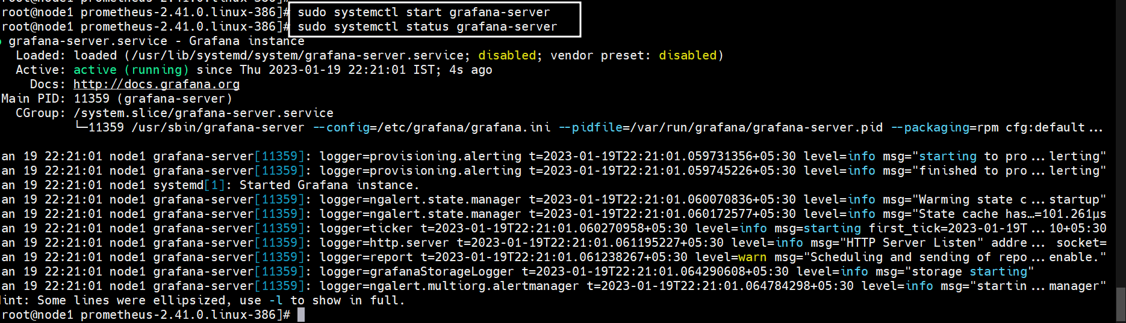

<http://your_ip:3000>

Here you can see Login page of Grafana now you will have to login with below Grafana default UserName and Password.

Username – admin

Password – admin

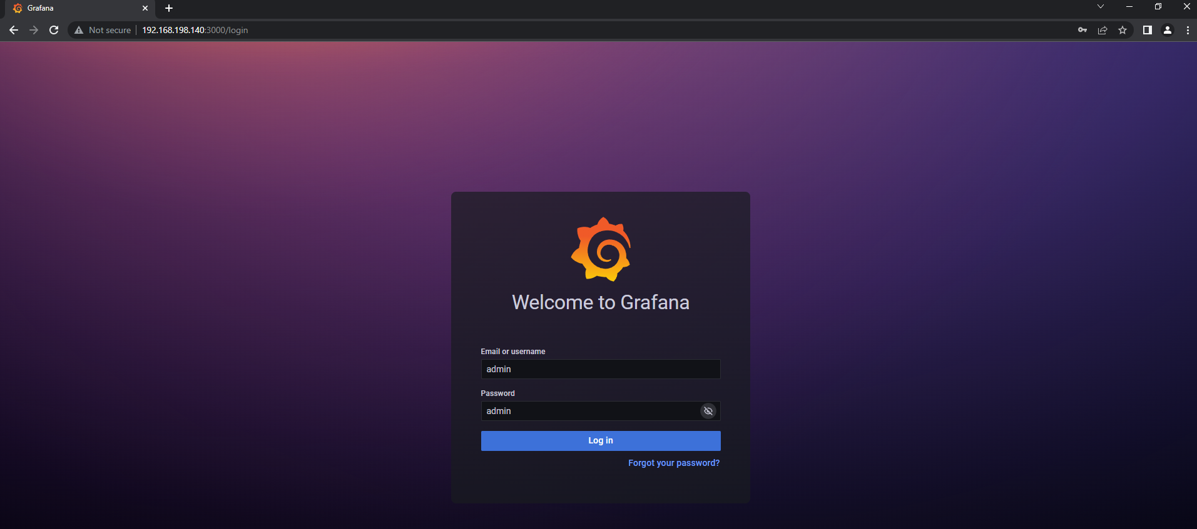

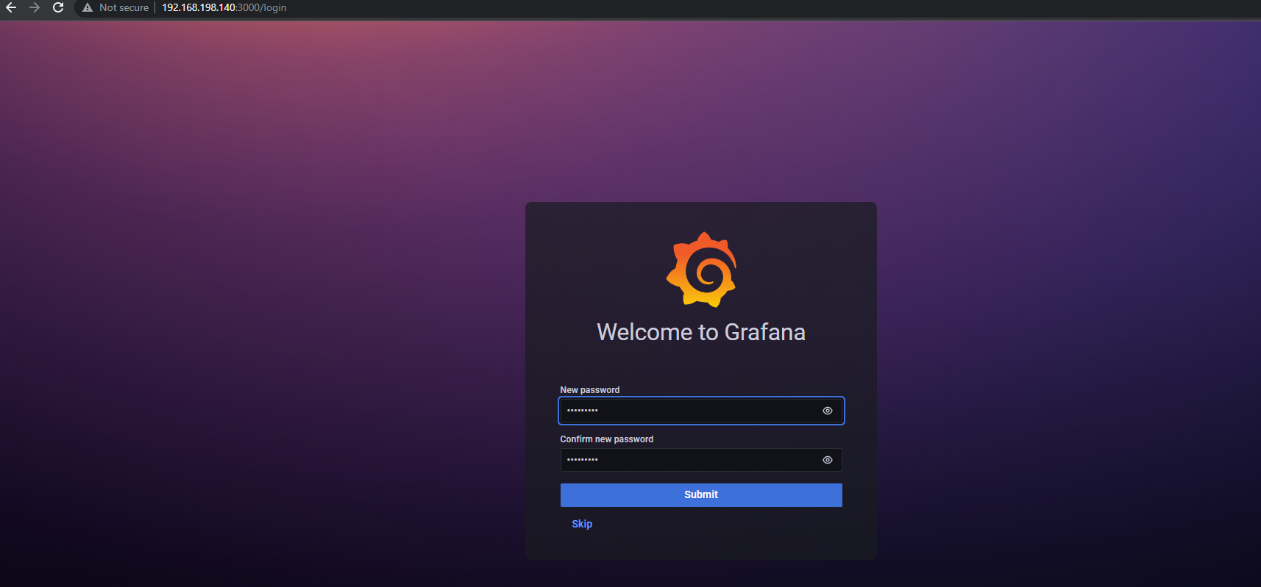

## **12. Configure Prometheus as Grafana Data Source**

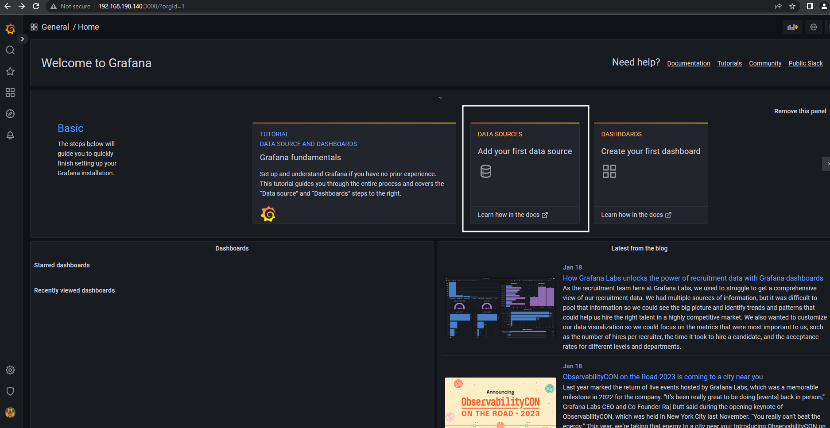

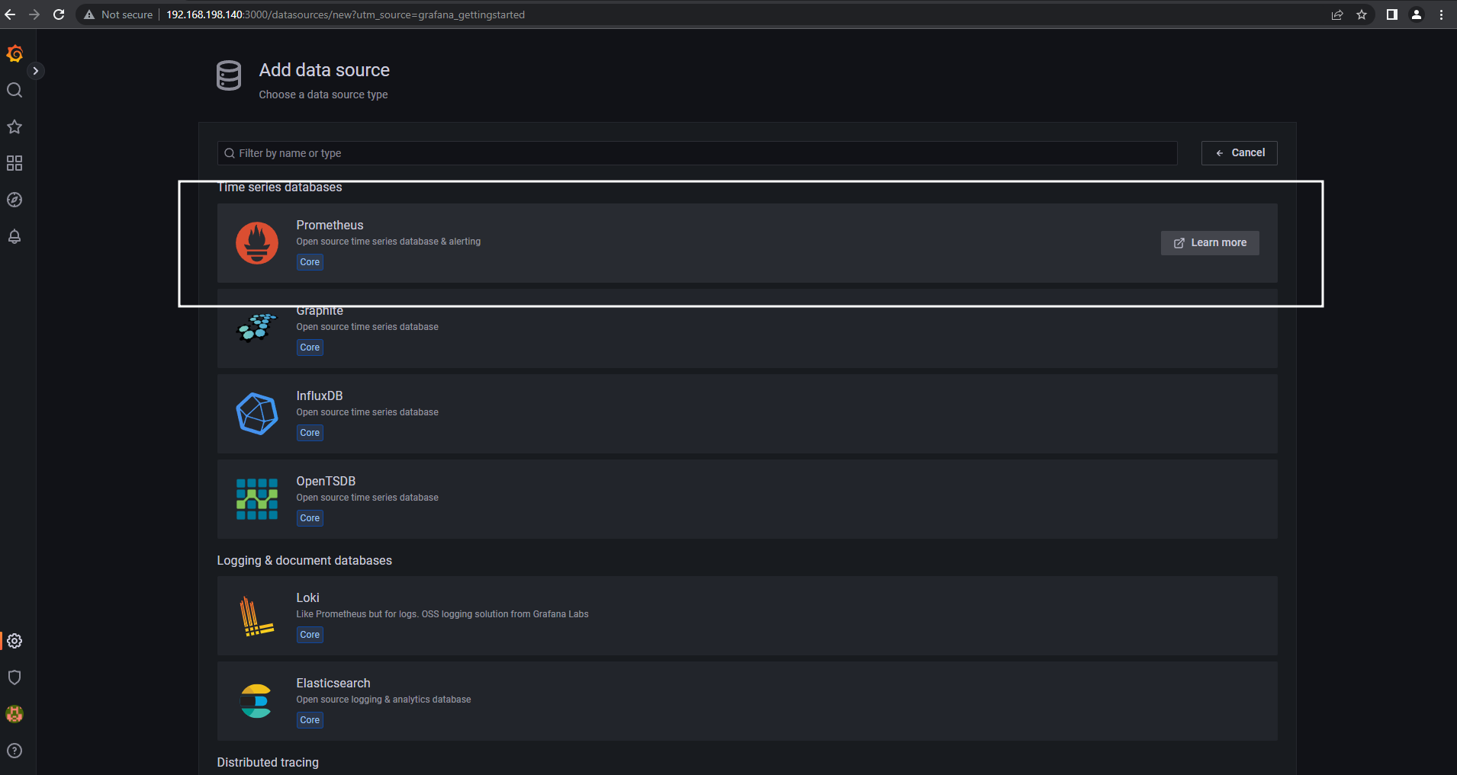

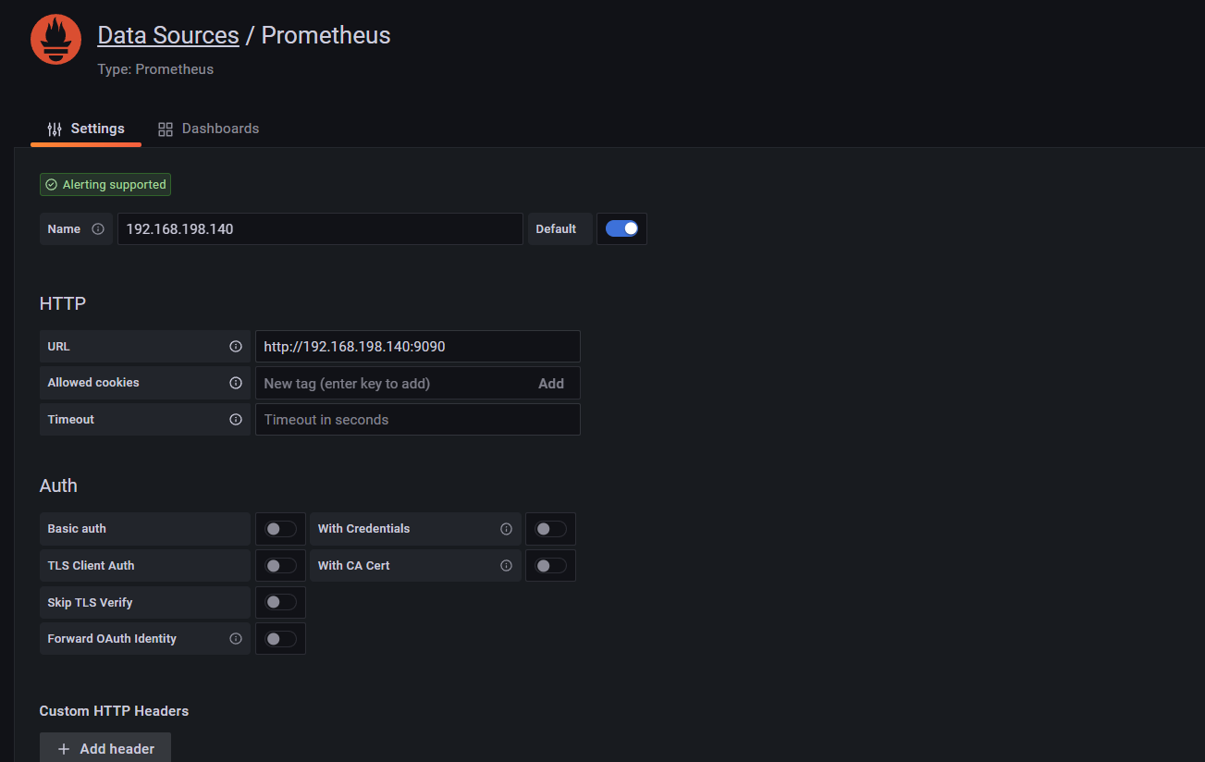

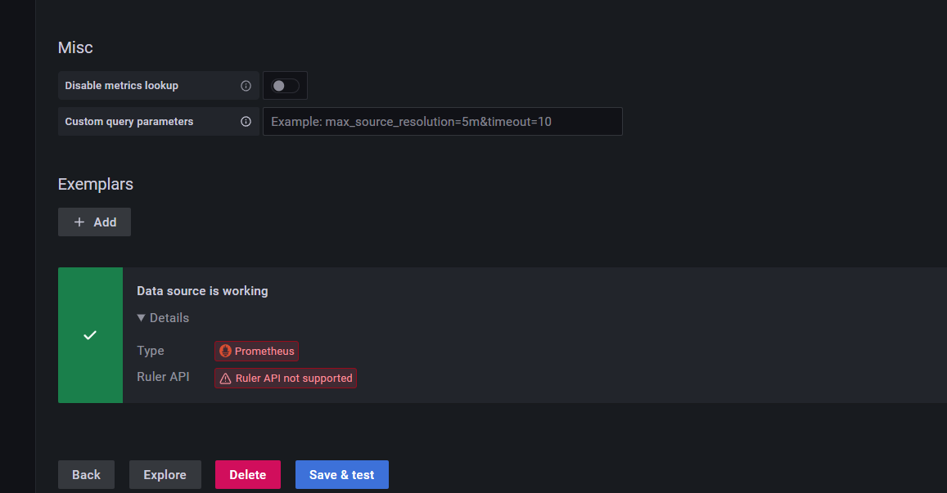

## #13**. Install Node Exporter on Linux**

Node Exporter collects the metrics of your system such as Memory usage, CPU usage, RAM, disk space, etc.

To install Node Exporter first navigate to [Prometheus official download page](https://prometheus.io/download/), Scroll down and you will get node_exporter section and then select Linux OS for amd64.

Now right click on node exporter and copy link address

Now lets run the copied URL with **wget** command

<https://prometheus.io/download/>

cd /tmp

wget <https://github.com/prometheus/node_exporter/releases/download/v1.5.0/node_exporter-1.5.0.linux-amd64.tar.gz>

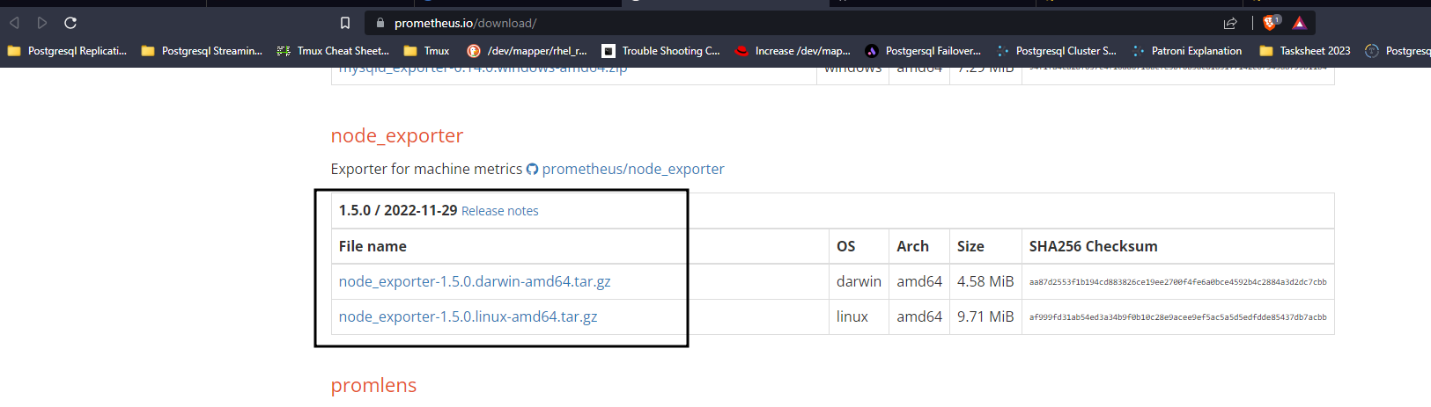

tar xvfz node_exporter-*.*-amd64.tar.gz

sudo mv node_exporter-*.*-amd64/node_exporter /usr/local/bin/

udo useradd -rs /bin/false node_exporter

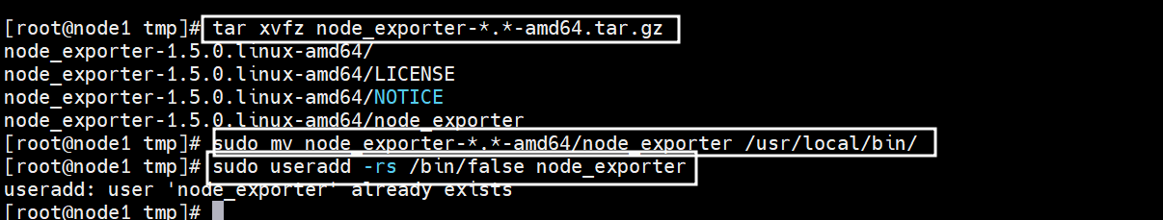

## #**14. Create a node_exporter service file in the /etc/systemd/system directory**



[Unit]

Description=Node Exporter

After=network.target

[Service]

User=node_exporter

Group=node_exporter

Type=simple

ExecStart=/usr/local/bin/node_exporter

[Install]

WantedBy=multi-user.target

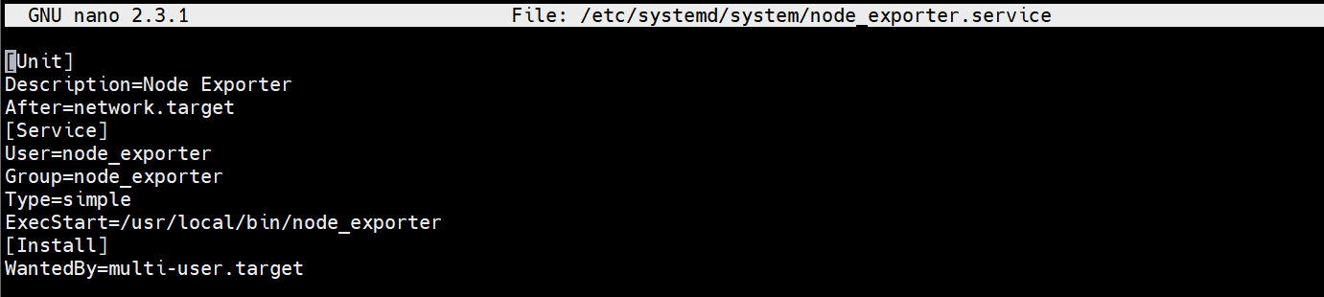

Now lets start and enable the node_exporter service using below commands

 sudo systemctl daemon-reload

sudo systemctl enable node_exporter

sudo systemctl start node_exporter

sudo systemctl status node_exporter

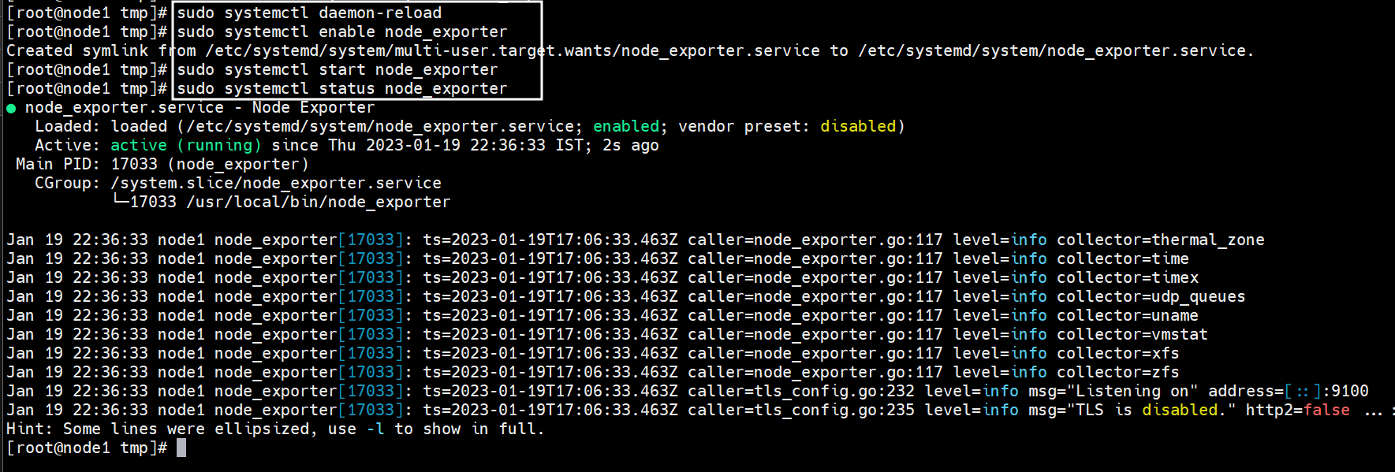

## #**15. Configure the Node Exporter as a Prometheus target**

-job_name: 'Node_Exporter'

scrape_interval: 5s

static_configs:

- targets: [SERVER-IP:9100']

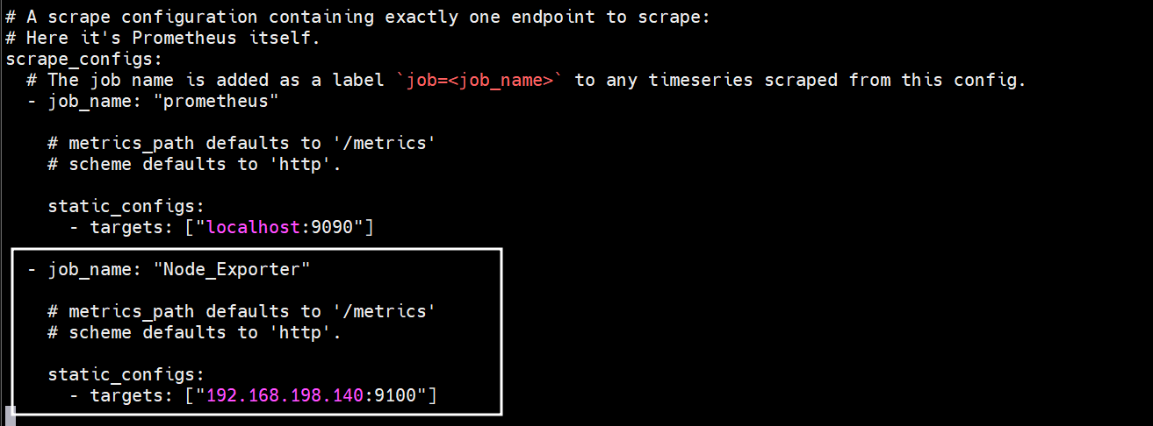

sudo systemctl restart Prometheus

sudo systemctl status Prometheus

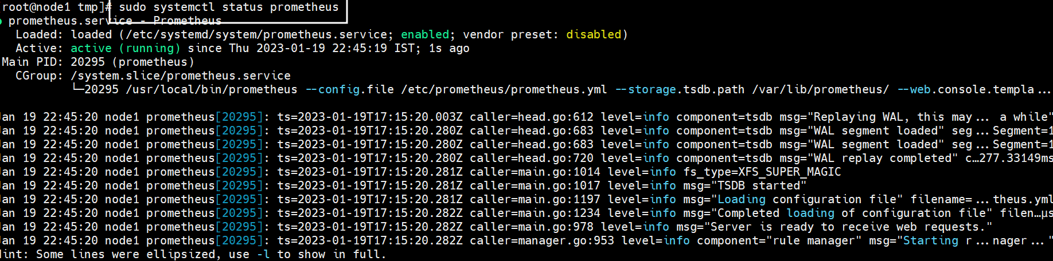

## #**16. Creating Grafana Dashboard to Monitor Linux Server**

Now lets build a dashboard in Grafana so then it will able to reflect the metrics of the Linux system.So we will use 14513 to import Grafana.com, Lets come to Grafana Home page and you can see a **“+”** icon. Click on that and select **“Import”**

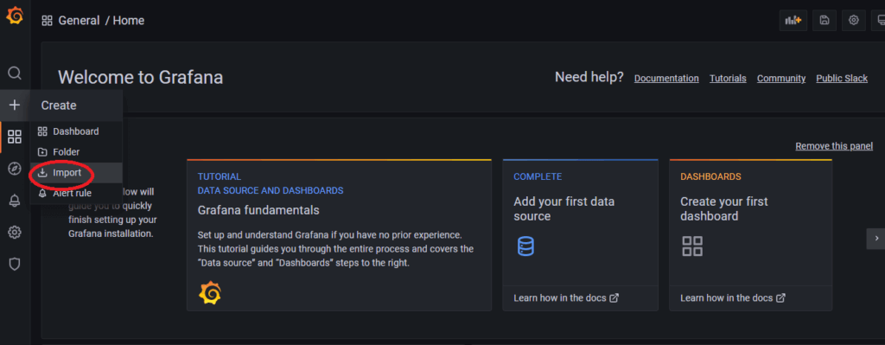

Now provide the Grafana.com Dashboard ID which is **14513**and click on **Load**

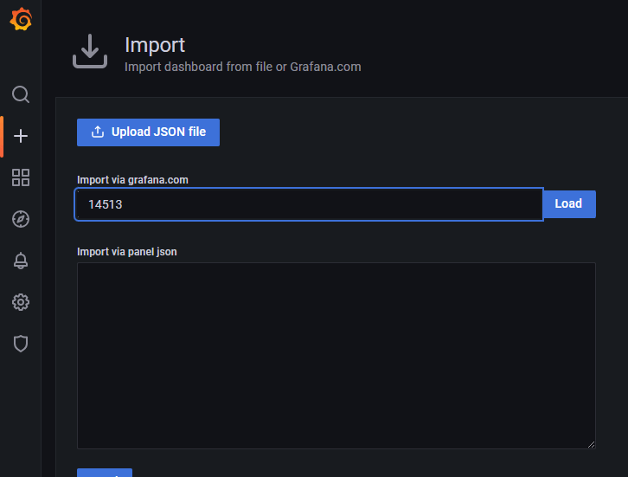

‘Now provide the name and select the Prometheus Datasource and click on Import.

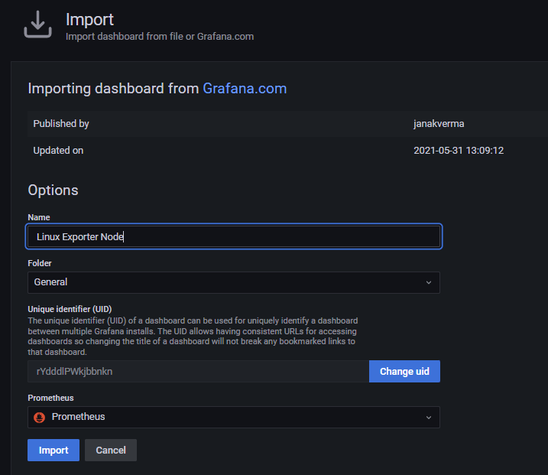

There you are done with the setup. Now your Dashboard is running up!.

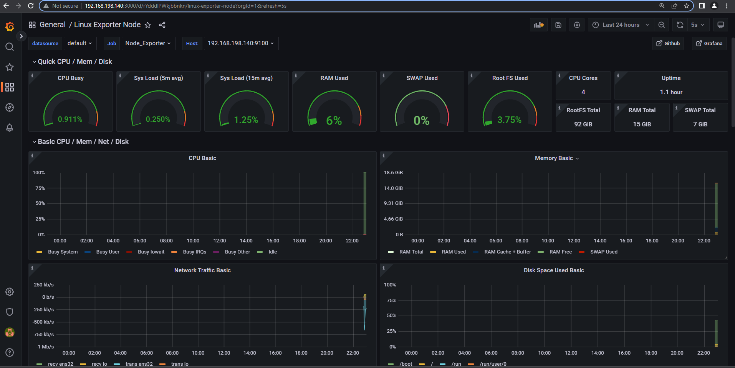

**#17. Install WMI Exporter on Windows**

For Windows hosts, you are going to use the Windows exporter.

You can download the latest version of windows installer from [here](https://github.com/prometheus-community/windows_exporter/releases)

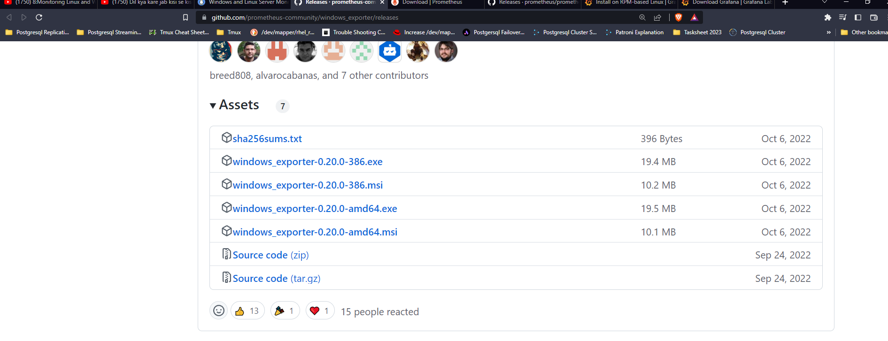

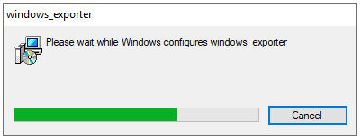

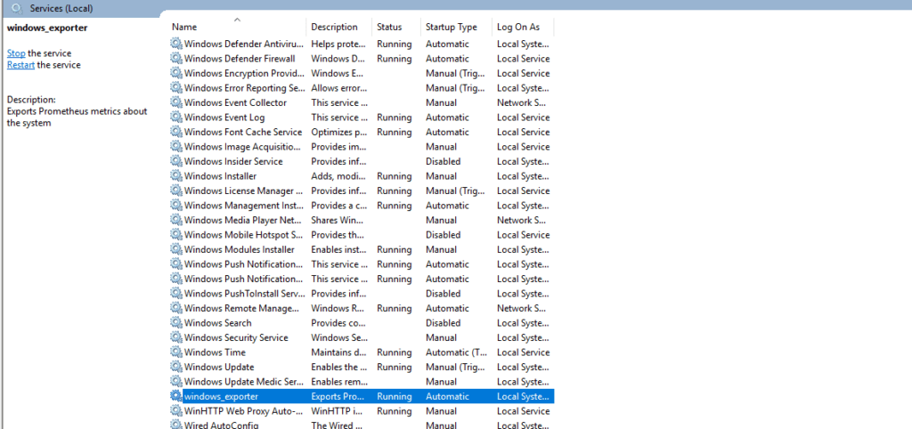



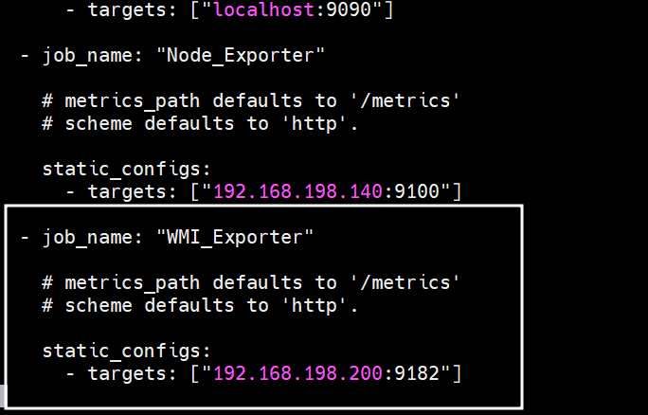

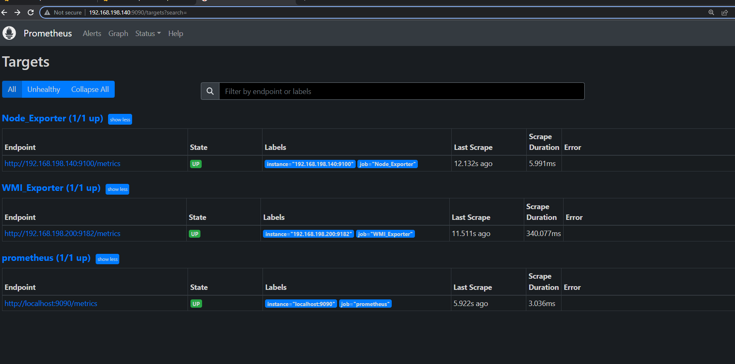

sudo systemctl restart Prometheus

sudo systemctl status Prometheus

## #**19. Creating Grafana Dashboard to monitor Windows server**

